

Music store

By:

Revati G Chavadal abhishek sharma

Section:koc50 section:koc50

Roll no:49 roll no:25



Table of content

1. Introduction
2. Technologies used
3. Features of the project
4. Flow of project
5. Bonafide certification

Introduction

The objective of this project is to implement. Online music web application with user interface. The motivation of this project comes from my desire to learn the increasingly growing field of Django server database designing, website designing and their growing popularity by taking up this project.

This is the website for online music store. The customer has to login to view his playlist. Random different songs are visible which

Technologyies used

HTML (Hyper Text Markup Language) is used to create electronic web page. Multiple web page can be created using HTML. These HTML web pages are connected to each other through hyperlink. HTML help to format proper label and text to our web page. HTML allow the browser to display text as elements and load images you want to add to you web page. HTML is compatible and easy language to create your web pages for your project.

CSS is designed primarily to enable the separation of presentation and content, including aspects such as the layout, colors, and fonts This separation can improve content accessibility, provide more flexibility and control in the specification of presentation characteristics, enable multiple HTML pages to share formatting by specifying the relevant CSS in a separate. CSS file, and reduce complexity and repetition in the structural content.

After creating web page using HTML coding, we need to style them to make them more attractive to users. CSS (Cascading Style Sheets) is used for this work.it help you make you website more different from others You may have 10-20 pages in your website, CSS help you to differentiate between all the websites by styling them. HTML is used to describe the content of website and we use CSS to style.

FEATURES OF THE PROJECT:

Major Features:

• “Play mp3”s streamed from the user server to the web client view.

• The music library sorted by various aspects such as: Artists, Album, Genre, Song Title; etc • Save and modify playlists through the web client.

• Use the users server to choose music to share to the web client.

• User permission for listening to music (Guest account that limit access to songs, etc) Minor Features:

• Encrypted TCP/IP communication.

• Multi-format support (Ogg Vorbis, FLAC, WMA, etc) Future Features:

• Consolidate music from different computer together for access from the web client.

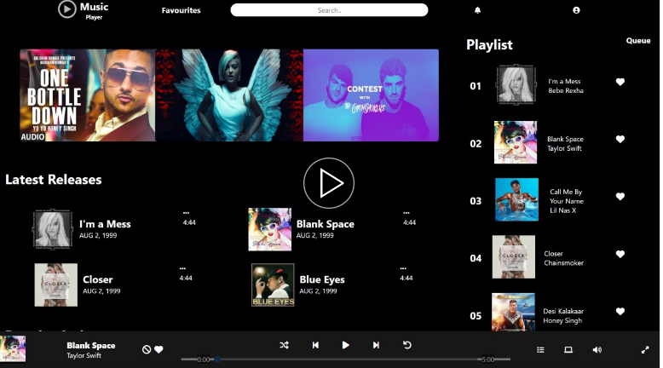

FLOW OF PROJECT TEAM ROLES:

FEATURE TEAMS We created web interface and website together. I created outlook and web interface. And server side interaction(playing mp3) also work on to make outlook of music store.

BONAFIDECERTIFICATE

Certified that this project report MUSIC STORE is the bonafied work , carried out the project work under my supervision.

Signature of the Supervisor

Name: Aashima Mam

Department of Supervisor: CSE

Thankyou;